Step1: Restore adventure works2014 database and create a different file groups

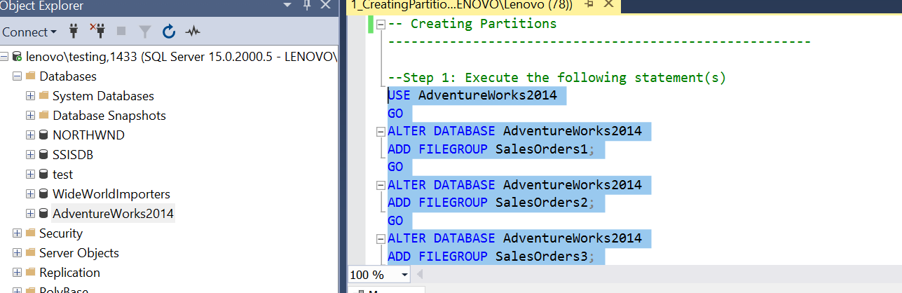

--Step 2: Execute the following statement(s)

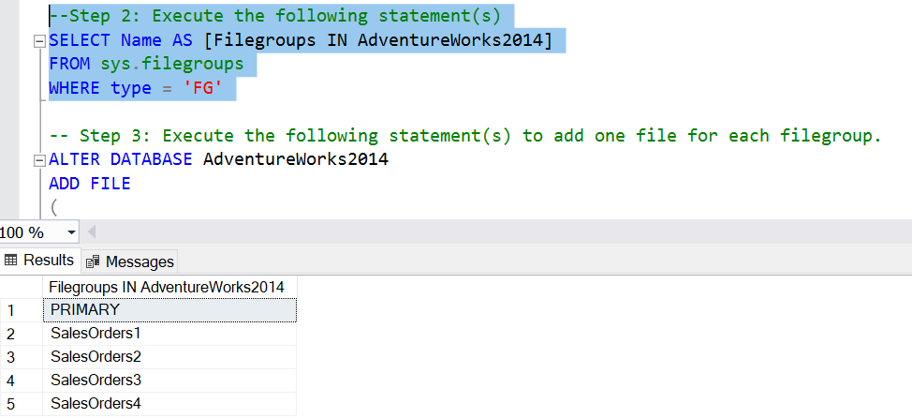

-- Step 3: Execute the following statement(s) to add one file for each filegroup.

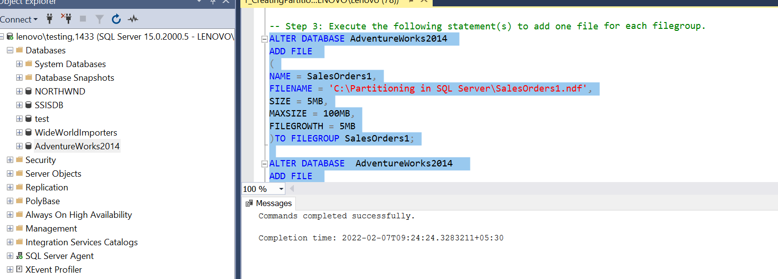

--Step 4: Execute the following statement(s) to create partition function

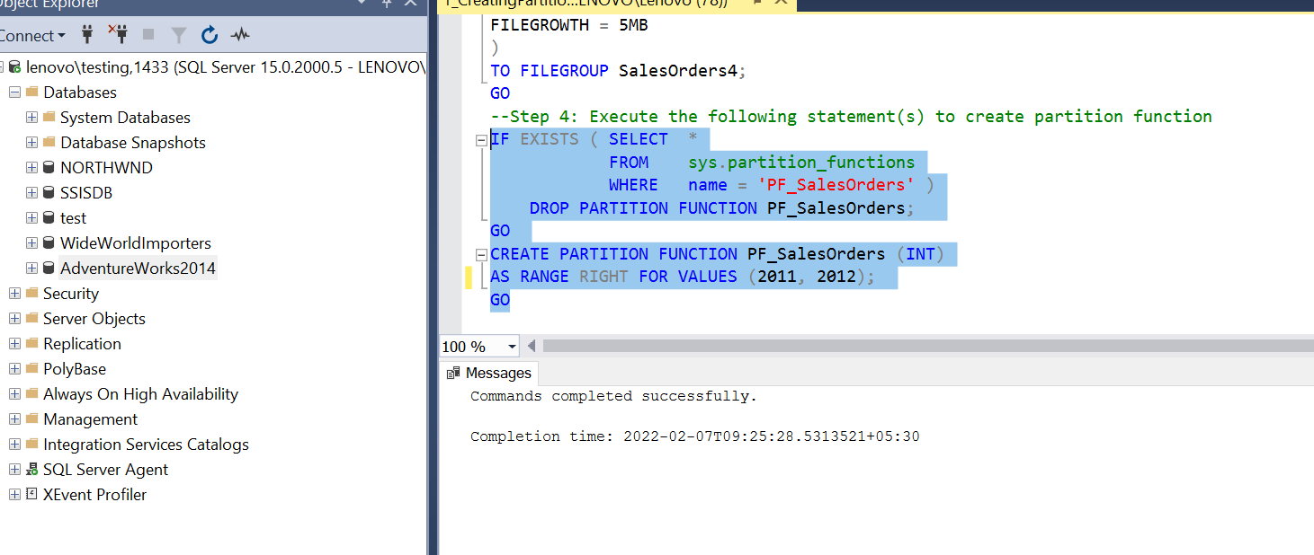

--Step 5: Execute the following statement(s) to view all partition functions in the database

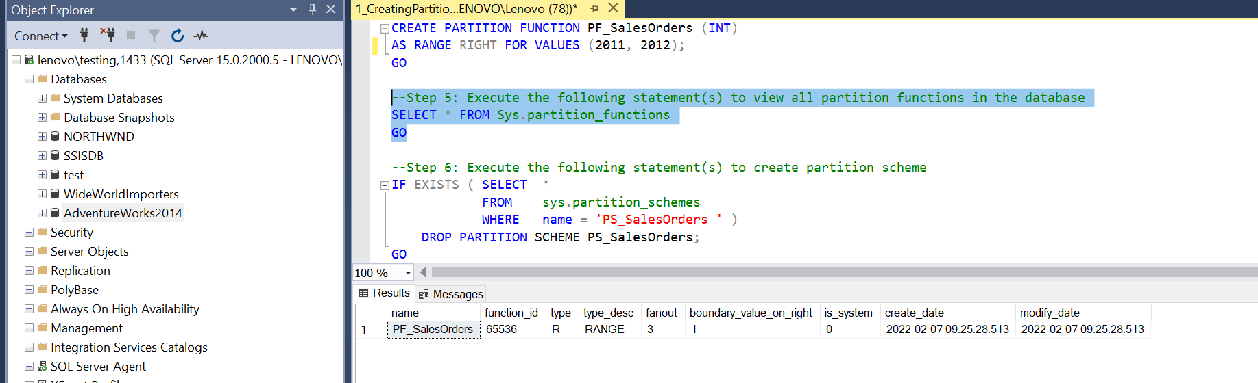

--Step 6: Execute the following statement(s) to create partition scheme

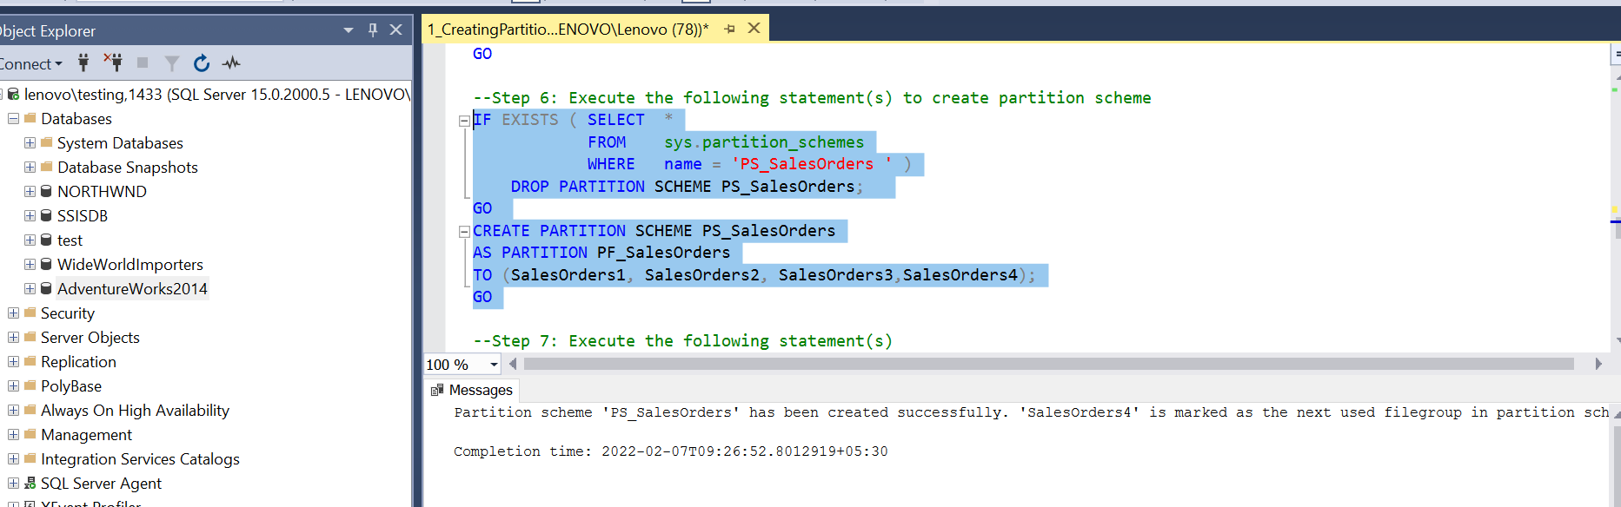

--Step 7: Execute the following statement(s)

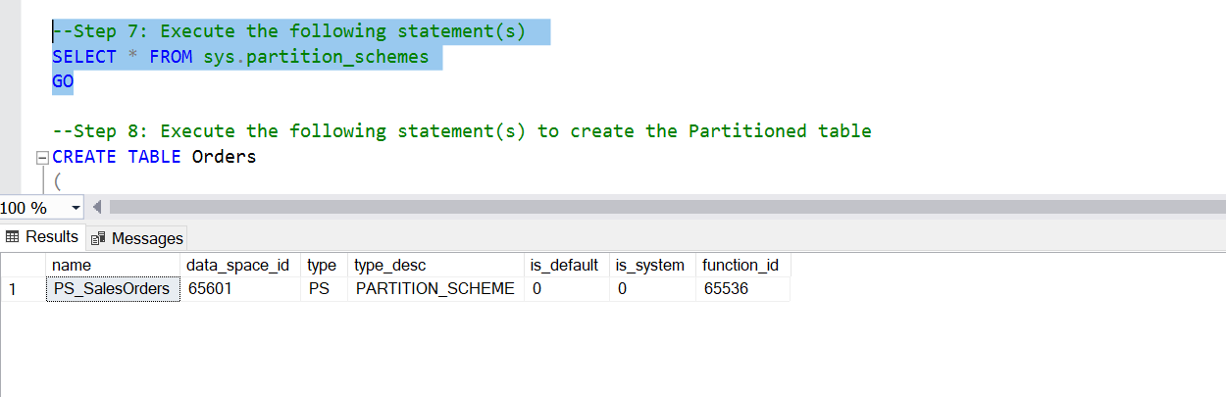

--Step 8: Execute the following statement(s) to create the Partitioned table

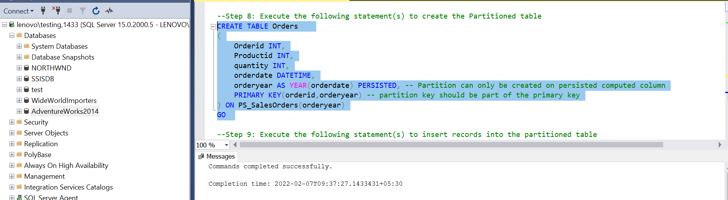

--Step 9: Execute the following statement(s) to insert records into the partitioned table

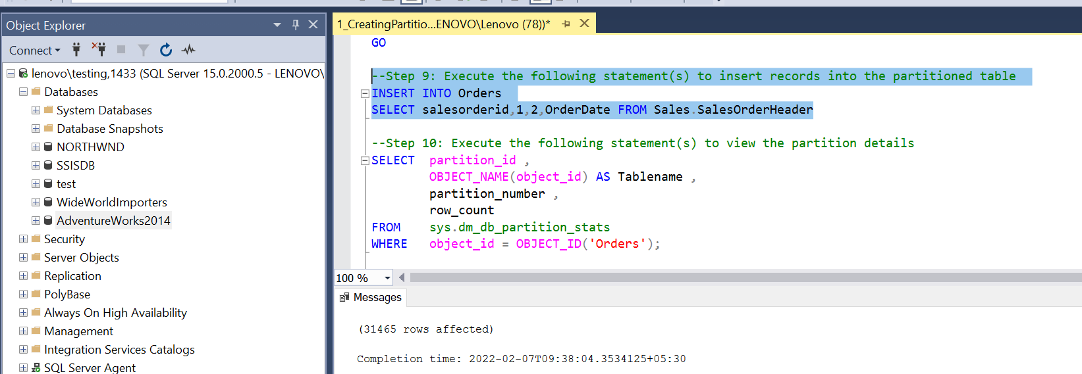

--Step 10: Execute the following statement(s) to view the partition details

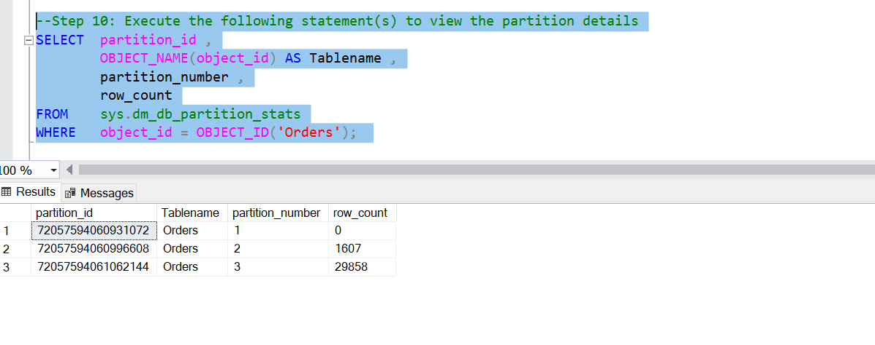

--NOTE:partition 2 contains 2011 data,and partition3 contains 2012,2013,2014 data.  
  
  
  
  
  
  
  
  
  
  
  
  
  
  
  
--Step 11: Execute the following statement(s) to get order count per year

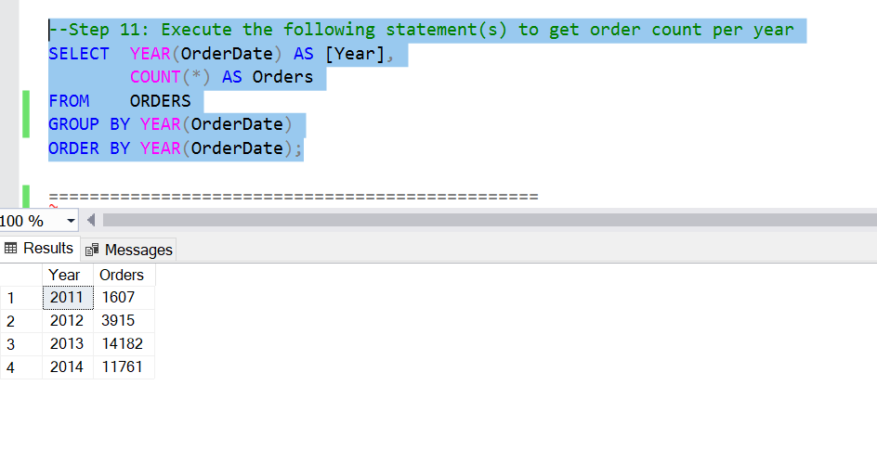

--Step 11: Execute the following statement(s)

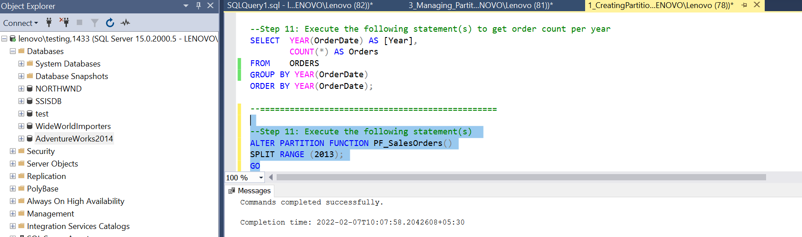

Marked for saleorder5 for next

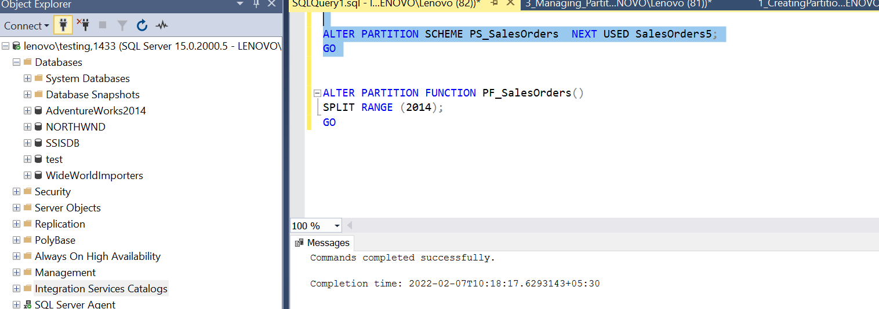

Splitting 2013 with 2014 –now new partition will contains 2014 and next year if any

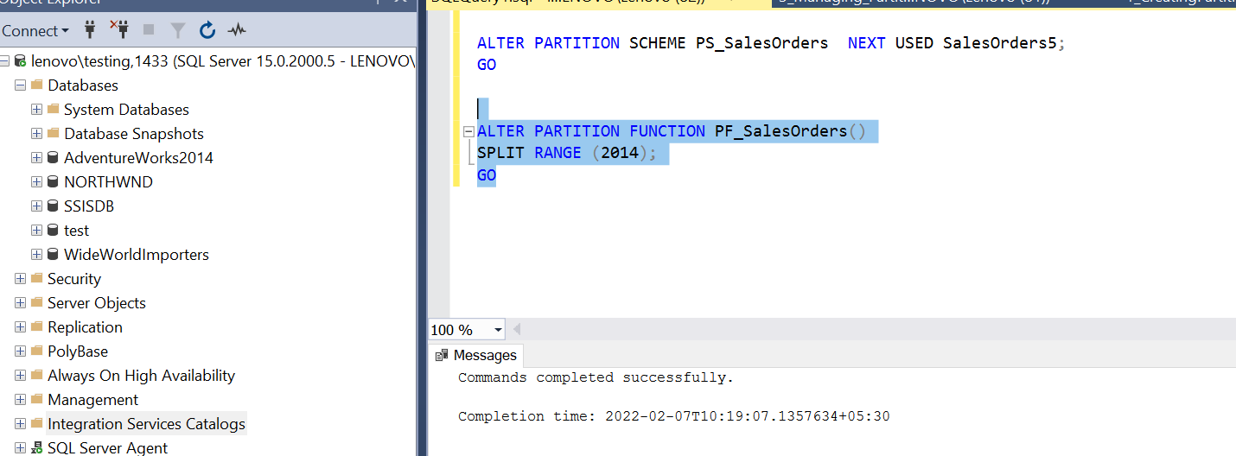

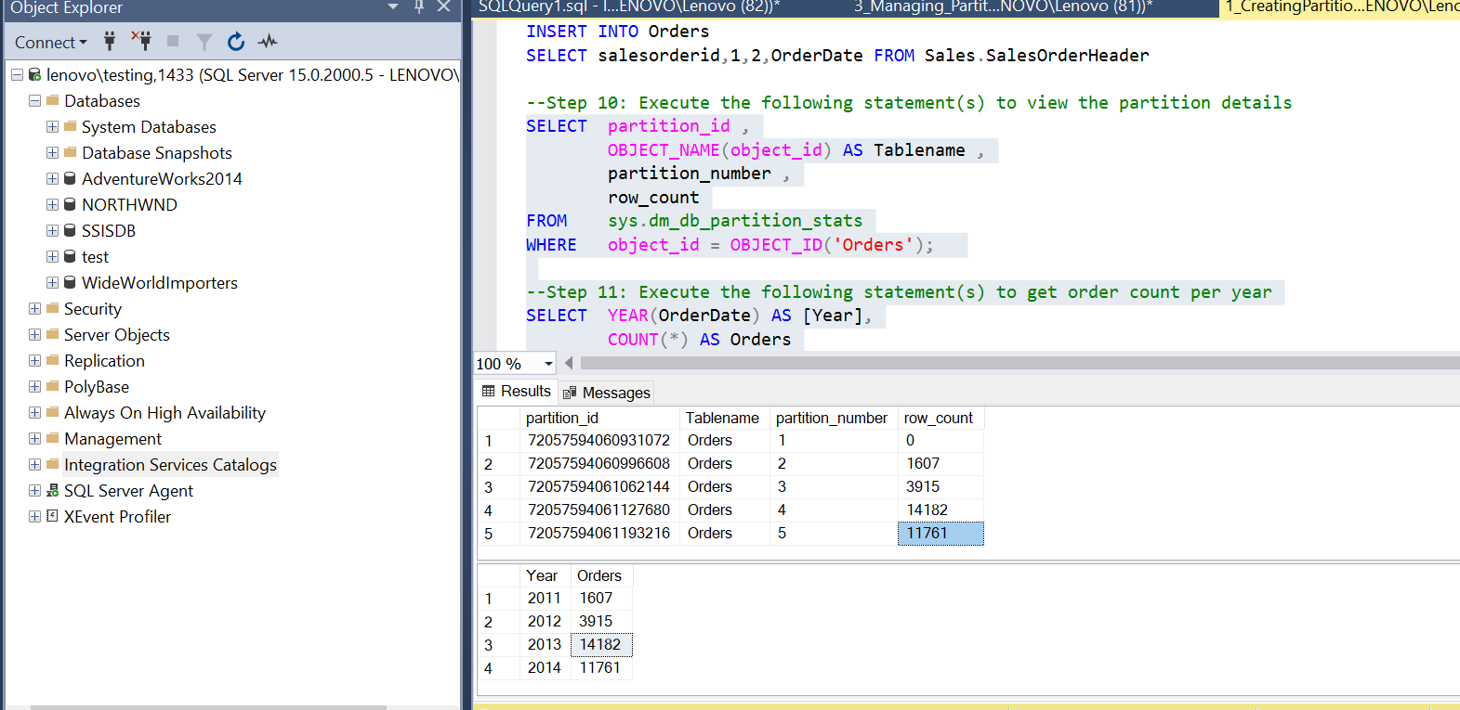

View the data according the new spit

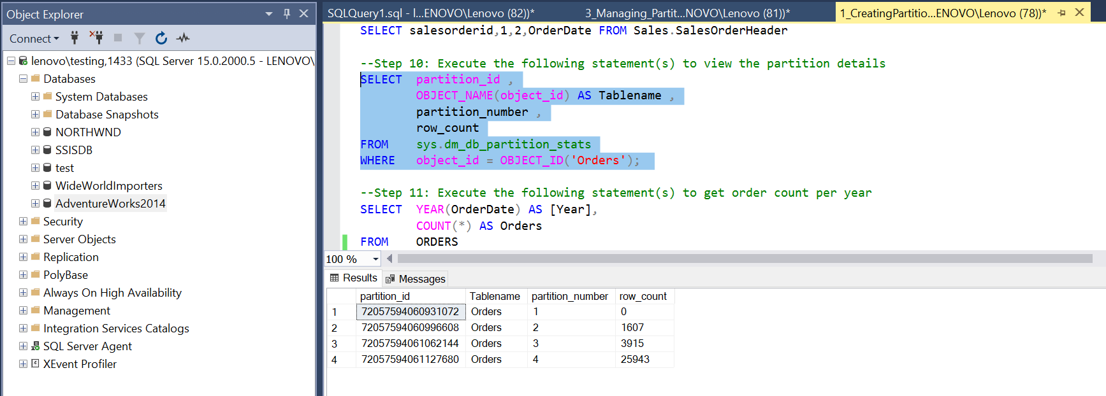

--now we need to divide the partition4which contains 2013 and 2014

